Using GitHub for GSA Crowd-Source Compatibility Test-Cycles

Thank You for agreeing to help us test out the use of GitHub for the Crowdsource test cycles.

For this first test cycles we will only be using it for discussions and issue tracking.

If you have any questions about GitHub that are not addressed here please direct them to the test-cycle leader.

Getting Started:

If you already have a GitHub username and password you can jump right into the next section “Using GitHub”.

If you have never used GitHub before you are in or a treat.

Go to <https://github.com/GSA>

Click Sign up and create your account.

All that you need to enter to create your account is: username, email address and password and you are set.

Using GitHub

Go to the GitHub project provided by the test-cycle leader.

Check to be sure you are in the correct project by looking at the Agency Name and test cycle dates in the “README.MD” file right in the middle of the first page.

Checking Discussions

From the main test cycle GitHub page.

Click on the “Issues” link on the right side of the page as shown below:

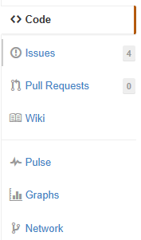

You should see an issue named “Discussion Forum” similar to the what is shown in the picture below:

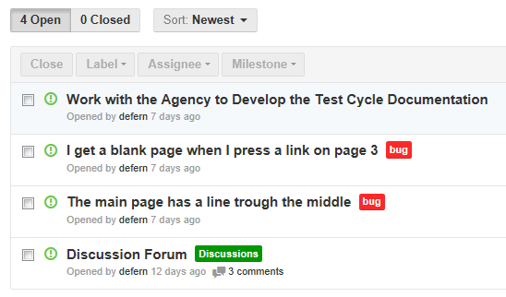

Click on “Discussion Forum” and you should see a thread where you can see what others are saying or asking and ask any question you may have or give feedback or help to other Testers.

This works like most other discussion boards.

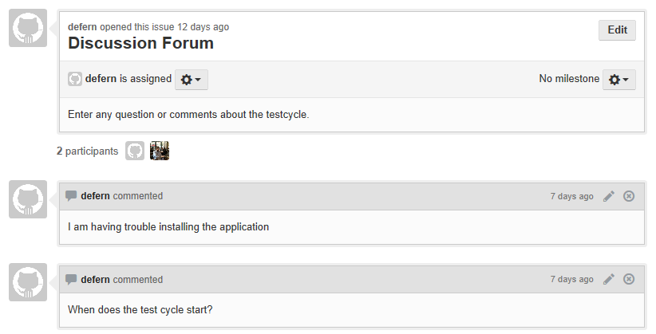

Viewing Issues

From the main test cycle GitHub page.

Click on the “Issues” link on the right side of the page as shown below:



You should see some issues similar to what is shown in the picture below:

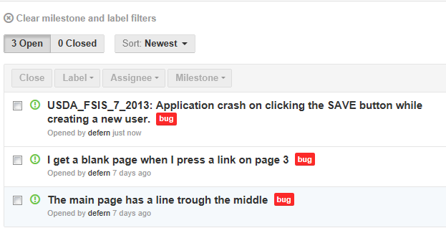

Click on any of the issues that you would like more detail on and they will open and look similar to the picture below.

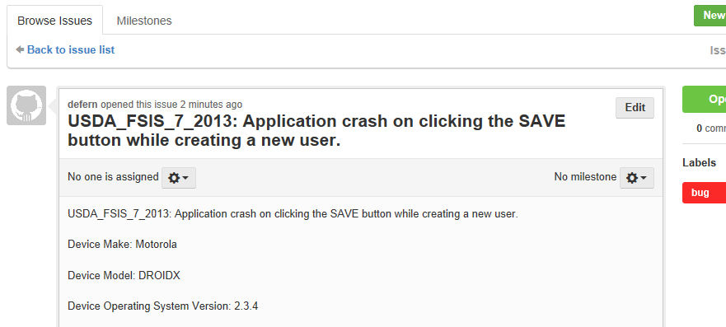

Adding Issues

From the main test cycle GitHub page.

Click on the “Issues” link on the right side of the page as shown below:



Click “New Issue” in the upper right corner that looks similar to the picture below.

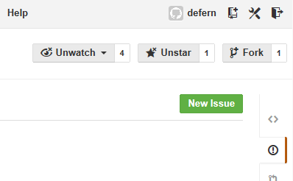

A bank issue will open and look similar to the picture below.

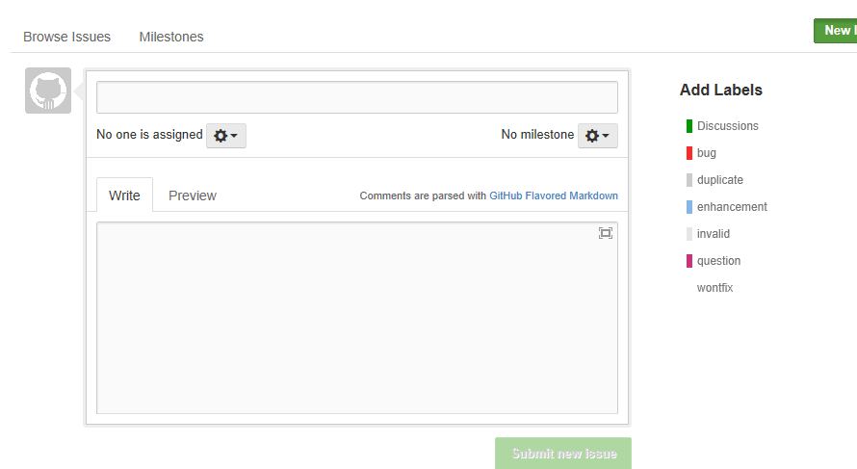

Enter information using the information below as a model:

**Issue Name:** USDA_FSIS_7_2013 - Application crash on clicking the SAVE button while creating a new user.

Be descriptive and start with the “USDA_FSIS_7_2013 -”

**Device Make:** Motorola

**Device Model:** DROIDX

**Device Operating System Version:** 2.3.4

**Browser:** Chrome

**Carrier (or WiFi):** Verizon

**Severity:** High,Medium, or Low

**Description:**  
Application crash on clicking the SAVE button while creating a new  
user, hence unable to create a new user in the application.

**Give a good description of what happened.**

**Steps To Reproduce:**  
**1)** Logon into the application  
**2)** Navigate to the Users Menu > New User  
**3)** Filled all the user information fields  
**4)** Clicked on ‘Save’ button  
**5)** Seen an error page “ORA1090 Exception: Insert values Error…”  
**6)** See the attached logs for more information (Attach more logs related to bug..IF any)  
**7)** And also see the attached screenshot of the error page.

**List the steps to reproduce the issue.**

**Expected result:** On clicking SAVE button, should be prompted to a success message “New User has been created successfully”.

What were you expecting to happen?

**Attach**: Save_Button_Issue.log, Save_Button_Issue_Screen_Shot.gig

The name of any log files or screen shots where possible.

Anything else of importance: The battery was very low.

Enter the information and press the information of the issue, select “Bug” from the “Add Labels“ to the right and press “Submit New Issue”.

The screen should look similar to the picture below.

